Prerequest :

Private ethereum blockchain / TestRPC
Truffle – for compile and deploy over ethereum network
Meteor JS for Front end and UI part.

Start testrpc/go ethereum from terminal window.
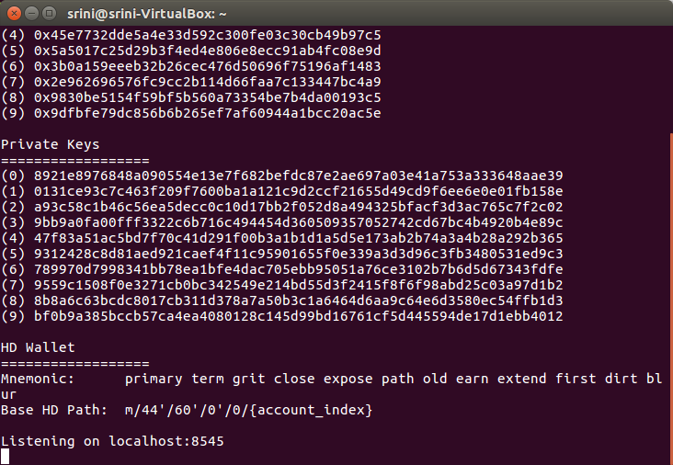

Recomended Api for meteor shown below.
From linux add the below mentioned package as example shown below.
srini@srini-VirtualBox: meteor add ethereum:web3
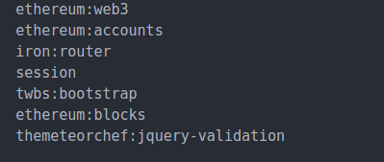

From the development package start meteor server as shown below. By typing meteor.
Meteor will start to run at localhost:3000 port

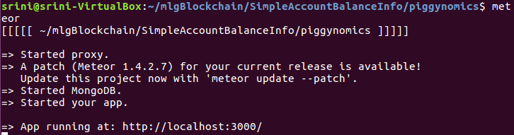

From Browser start the http://localhost:3000/

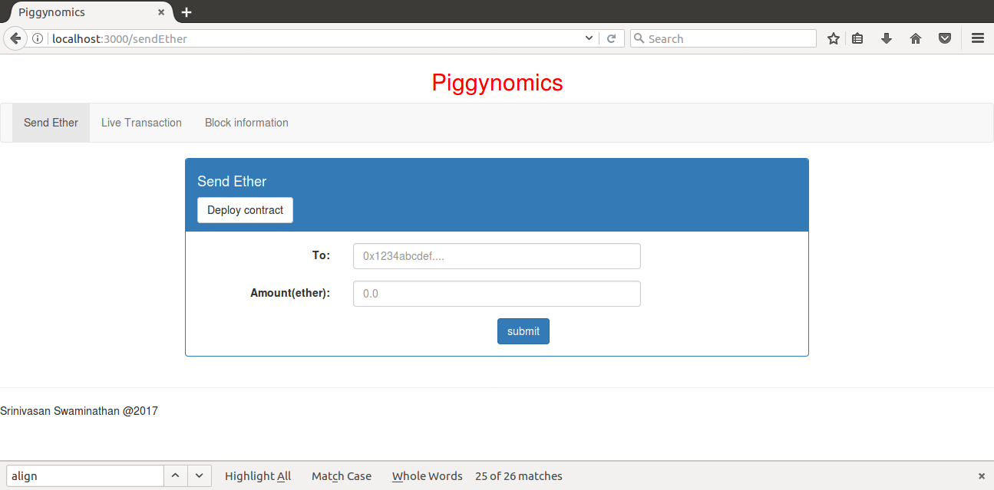

Deploy the contract on to ethereum blockchain.

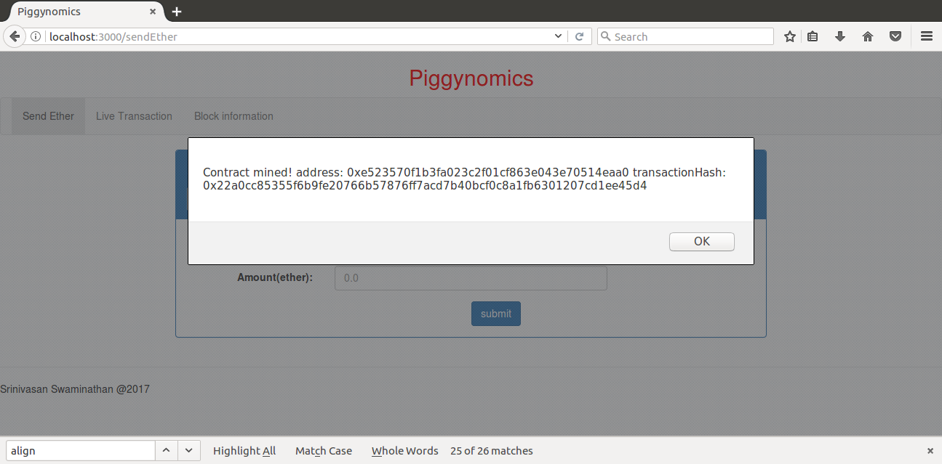

Start to send tokens to another address.

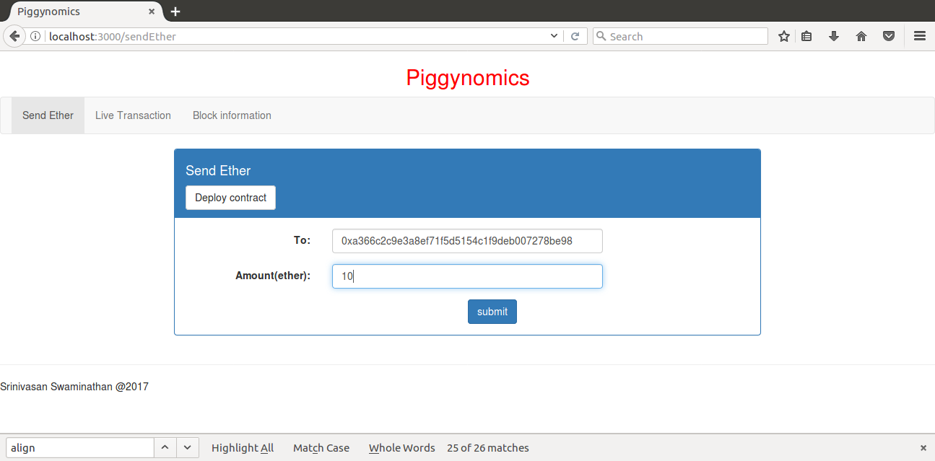

Click Submit button, will popup with confirmation window.

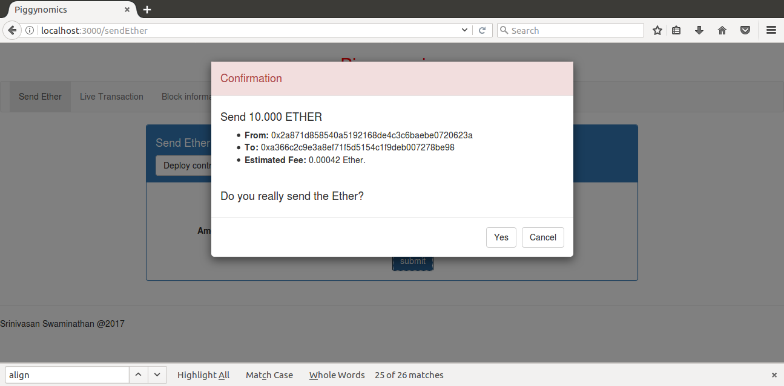

Alert to show transaction success

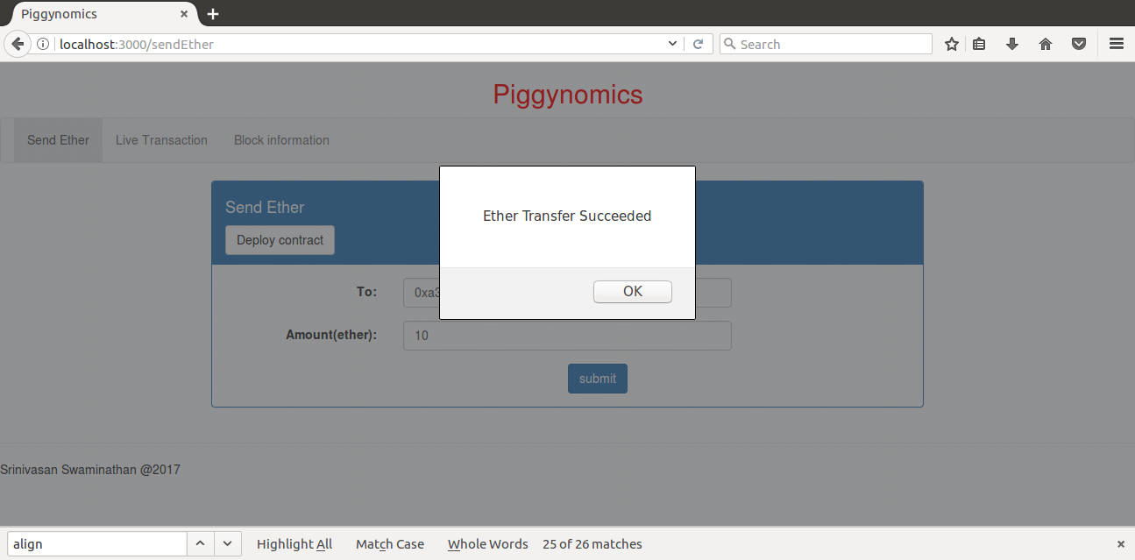

followed with that alert to show the msg.sender account balance.

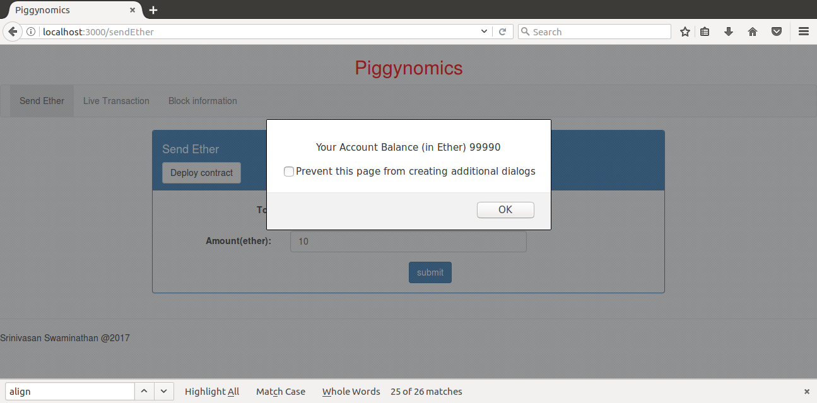
Let repeate to send tokens for 4 or more transactions to different accounts

all the transactions are tracked in another screen (Live Transaction) as shown below with From, To address Block height, Block date time, Transaction Date Time details amount of ether spent and each transaction block number.

current latest 5 transaction will keep on update.

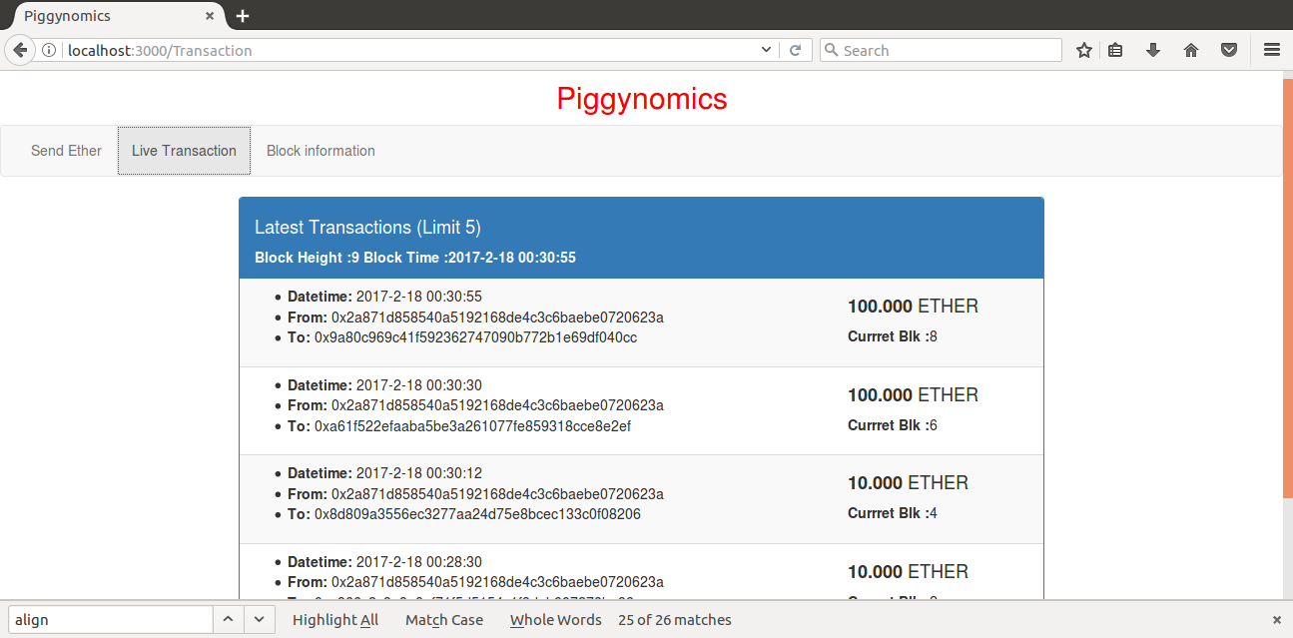

Also it has facility to get the block information on giving block number. As shown below.

